

KK14203 OBJECT ORIENTED PROGRAMMING

SEMESTER II

SESSION 2019/2020

ASSIGNMENT 3

LECTURER: MADAM SITI HASNAH TANALOL

MADE BY:MOHD RIDHWAN BIN MOHAMED

Objective

1. Easy to use than use paper.
2. Objetif is to make sure all customer data save for reference
3. This system easy to use and save time when customer want to go shop

Case Diagram

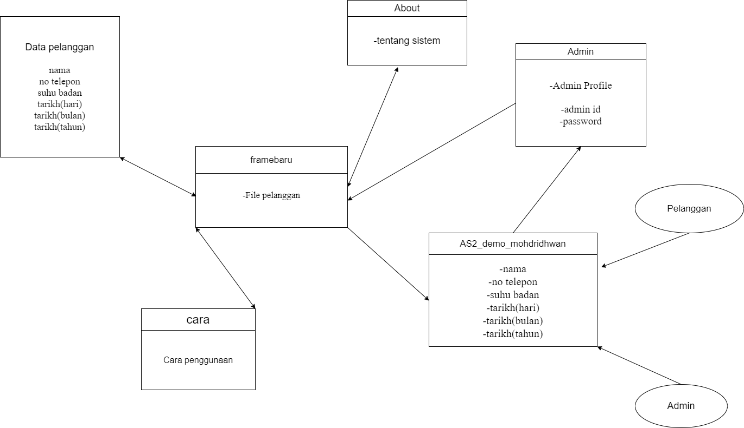

**Coding**

**Main**

import java.awt.HeadlessException;

import java.awt.Toolkit;

import java.io.FileWriter;

import java.io.IOException;

import javax.swing.JOptionPane;

/*

* To change this license header, choose License Headers in Project Properties.

* To change this template file, choose Tools | Templates

* and open the template in the editor.

*/

/**

*

* @author User

*/

public class AS2_demo_mohdridhwan extends javax.swing.JFrame {

/**

* Creates new form AS2_demo_mohdridhwan

*/

public AS2_demo_mohdridhwan() {

initComponents();

setResizable(false);

setSize(850,570);

setLocation(600,200);

setTitle(" BILIK PERGERAKAN COVID19");

setIcon();

}

/**

* This method is called from within the constructor to initialize the form.

* WARNING: Do NOT modify this code. The content of this method is always

* regenerated by the Form Editor.

*/

@SuppressWarnings("unchecked")

// <editor-fold defaultstate="collapsed" desc="Generated Code">

private void initComponents() {

jLabel1 = new javax.swing.JLabel();

jLabel2 = new javax.swing.JLabel();

namatxt = new javax.swing.JTextField();

alamattxt = new javax.swing.JTextField();

notxt = new javax.swing.JTextField();

jLabel3 = new javax.swing.JLabel();

jLabel4 = new javax.swing.JLabel();

jButton1 = new javax.swing.JButton();

jLabel5 = new javax.swing.JLabel();

jLabel6 = new javax.swing.JLabel();

jLabel7 = new javax.swing.JLabel();

jLabel8 = new javax.swing.JLabel();

jLabel10 = new javax.swing.JLabel();

jButton2 = new javax.swing.JButton();

jButton4 = new javax.swing.JButton();

jButton5 = new javax.swing.JButton();

j1 = new javax.swing.JComboBox<>();

j2 = new javax.swing.JComboBox<>();

j3 = new javax.swing.JComboBox<>();

tar3 = new javax.swing.JTextField();

tar = new javax.swing.JTextField();

tar2 = new javax.swing.JTextField();

jLabel9 = new javax.swing.JLabel();

setDefaultCloseOperation(javax.swing.WindowConstants.EXIT_ON_CLOSE);

getContentPane().setLayout(null);

jLabel1.setFont(new java.awt.Font("Tahoma", 1, 14)); // NOI18N

jLabel1.setText("NAMA PENUH");

getContentPane().add(jLabel1);

jLabel1.setBounds(60, 130, 110, 17);

jLabel2.setFont(new java.awt.Font("Tahoma", 1, 14)); // NOI18N

jLabel2.setText("SUHU BADAN");

getContentPane().add(jLabel2);

jLabel2.setBounds(60, 180, 120, 20);

namatxt.setBackground(new java.awt.Color(102, 102, 102));

namatxt.setFont(new java.awt.Font("Tahoma", 1, 13)); // NOI18N

namatxt.setForeground(new java.awt.Color(255, 255, 255));

namatxt.addActionListener(new java.awt.event.ActionListener() {

public void actionPerformed(java.awt.event.ActionEvent evt) {

namatxtActionPerformed(evt);

}

});

getContentPane().add(namatxt);

namatxt.setBounds(250, 120, 230, 30);

alamattxt.setBackground(new java.awt.Color(102, 102, 102));

alamattxt.setFont(new java.awt.Font("Tahoma", 1, 13)); // NOI18N

alamattxt.setForeground(new java.awt.Color(255, 255, 255));

getContentPane().add(alamattxt);

alamattxt.setBounds(250, 170, 230, 30);

notxt.setBackground(new java.awt.Color(102, 102, 102));

notxt.setFont(new java.awt.Font("Tahoma", 1, 13)); // NOI18N

notxt.setForeground(new java.awt.Color(255, 255, 255));

getContentPane().add(notxt);

notxt.setBounds(250, 222, 230, 30);

jLabel3.setFont(new java.awt.Font("Tahoma", 1, 14)); // NOI18N

jLabel3.setText("NO TELEPON");

getContentPane().add(jLabel3);

jLabel3.setBounds(60, 230, 130, 20);

jLabel4.setFont(new java.awt.Font("Tahoma", 1, 14)); // NOI18N

jLabel4.setText("TARIKH (HH/BB/TTTT)");

getContentPane().add(jLabel4);

jLabel4.setBounds(60, 290, 170, 20);

jButton1.setBackground(new java.awt.Color(102, 102, 102));

jButton1.setFont(new java.awt.Font("Tahoma", 1, 13)); // NOI18N

jButton1.setText("Save");

jButton1.addActionListener(new java.awt.event.ActionListener() {

public void actionPerformed(java.awt.event.ActionEvent evt) {

jButton1ActionPerformed(evt);

}

});

getContentPane().add(jButton1);

jButton1.setBounds(250, 340, 110, 25);

jLabel5.setFont(new java.awt.Font("Serif", 1, 24)); // NOI18N

jLabel5.setForeground(new java.awt.Color(255, 255, 255));

jLabel5.setText("SELAMAT DATANG KEDAI HAJI MOHD RIDHWAN");

getContentPane().add(jLabel5);

jLabel5.setBounds(120, 30, 620, 47);

jLabel6.setFont(new java.awt.Font("Tahoma", 3, 14)); // NOI18N

jLabel6.setText("Design by E.1");

getContentPane().add(jLabel6);

jLabel6.setBounds(10, 500, 166, 30);

jLabel7.setFont(new java.awt.Font("Tahoma", 1, 14)); // NOI18N

jLabel7.setText("*SILA GUNA PENUTUP MUKA SEBELUM MASUK PREMIS INI DAN AMALKAN PENJARAKAN SOSIAL * ");

getContentPane().add(jLabel7);

jLabel7.setBounds(60, 400, 710, 17);

jLabel8.setBackground(new java.awt.Color(0, 0, 0));

jLabel8.setIcon(new javax.swing.ImageIcon("C:\\Users\\User\\Documents\\NetBeansProjects\\Projek_bilik_pergerakan\\src\\BILIK PERGERAKAN ONLINE.png")); // NOI18N

getContentPane().add(jLabel8);

jLabel8.setBounds(580, 130, 200, 210);

jLabel10.setFont(new java.awt.Font("Tahoma", 1, 14)); // NOI18N

jLabel10.setText("Daftar Online");

getContentPane().add(jLabel10);

jLabel10.setBounds(630, 340, 90, 17);

jButton2.setBackground(new java.awt.Color(102, 102, 102));

jButton2.setFont(new java.awt.Font("Tahoma", 1, 13)); // NOI18N

jButton2.setText("Admin");

jButton2.addActionListener(new java.awt.event.ActionListener() {

public void actionPerformed(java.awt.event.ActionEvent evt) {

jButton2ActionPerformed(evt);

}

});

getContentPane().add(jButton2);

jButton2.setBounds(370, 490, 110, 25);

jButton4.setBackground(new java.awt.Color(102, 102, 102));

jButton4.setFont(new java.awt.Font("Tahoma", 1, 13)); // NOI18N

jButton4.setText("Reset");

jButton4.addActionListener(new java.awt.event.ActionListener() {

public void actionPerformed(java.awt.event.ActionEvent evt) {

jButton4ActionPerformed(evt);

}

});

getContentPane().add(jButton4);

jButton4.setBounds(370, 340, 110, 25);

jButton5.setBackground(new java.awt.Color(102, 102, 102));

jButton5.setFont(new java.awt.Font("Tahoma", 1, 13)); // NOI18N

jButton5.setText("Keluar");

jButton5.addActionListener(new java.awt.event.ActionListener() {

public void actionPerformed(java.awt.event.ActionEvent evt) {

jButton5ActionPerformed(evt);

}

});

getContentPane().add(jButton5);

jButton5.setBounds(250, 490, 110, 25);

j1.setBackground(new java.awt.Color(102, 102, 102));

j1.setFont(new java.awt.Font("Tahoma", 1, 13)); // NOI18N

j1.setModel(new javax.swing.DefaultComboBoxModel<>(new String[] { "1", "2", "3", "4", "5", "6", "7", "8", "9", "10", "11", "12", "13", "14", "15", "16", "17", "18", "19", "20", "21", "22", "23", "24", "25", "26", "27", "28", "29", "30" }));

j1.addActionListener(new java.awt.event.ActionListener() {

public void actionPerformed(java.awt.event.ActionEvent evt) {

j1ActionPerformed(evt);

}

});

getContentPane().add(j1);

j1.setBounds(250, 280, 70, 30);

j2.setBackground(new java.awt.Color(102, 102, 102));

j2.setFont(new java.awt.Font("Tahoma", 1, 13)); // NOI18N

j2.setModel(new javax.swing.DefaultComboBoxModel<>(new String[] { "01", "02", "03", "04", "05", "06", "07", "08", "09", "10", "11", "12" }));

j2.addActionListener(new java.awt.event.ActionListener() {

public void actionPerformed(java.awt.event.ActionEvent evt) {

j2ActionPerformed(evt);

}

});

getContentPane().add(j2);

j2.setBounds(330, 280, 70, 30);

j3.setBackground(new java.awt.Color(102, 102, 102));

j3.setFont(new java.awt.Font("Tahoma", 1, 13)); // NOI18N

j3.setModel(new javax.swing.DefaultComboBoxModel<>(new String[] { "2019", "2020", "2021", "2022", "2023", "2024", "2025", "2026", "2027", "2028", "2029", "2030" }));

j3.addActionListener(new java.awt.event.ActionListener() {

public void actionPerformed(java.awt.event.ActionEvent evt) {

j3ActionPerformed(evt);

}

});

getContentPane().add(j3);

j3.setBounds(410, 280, 70, 30);

tar3.addActionListener(new java.awt.event.ActionListener() {

public void actionPerformed(java.awt.event.ActionEvent evt) {

tar3ActionPerformed(evt);

}

});

getContentPane().add(tar3);

tar3.setBounds(430, 290, 10, 10);

tar.addActionListener(new java.awt.event.ActionListener() {

public void actionPerformed(java.awt.event.ActionEvent evt) {

tarActionPerformed(evt);

}

});

getContentPane().add(tar);

tar.setBounds(270, 290, 20, 0);

getContentPane().add(tar2);

tar2.setBounds(350, 290, 40, 0);

jLabel9.setFont(new java.awt.Font("Tahoma", 1, 13)); // NOI18N

jLabel9.setIcon(new javax.swing.ImageIcon("C:\\Users\\User\\Documents\\NetBeansProjects\\Projek_bilik_pergerakan\\src\\waving-flag-of-is-a-region-of-malaysiar-vector-22515194.jpg")); // NOI18N

getContentPane().add(jLabel9);

jLabel9.setBounds(-20, -30, 860, 800);

pack();

}// </editor-fold>

private void jButton1ActionPerformed(java.awt.event.ActionEvent evt) {

String nama= namatxt.getText();

String phone= notxt.getText();

String alamat= alamattxt.getText();

String tarikh= tar.getText();

String tarikh2=tar2.getText();

String tarikh3=tar3.getText();

try {

try (FileWriter writer = new FileWriter("Data pelanggan", true)) {

writer.write("....................................");

writer.write(System.getProperty("line.separator"));

writer.write("Nama : ");

writer.write(nama);

writer.write(System.getProperty("line.separator")); //untuk line baru supaya tidak bercampur dengan input yang pertama

writer.write("Suhu Badan : ");

writer.write(phone);

writer.write(System.getProperty("line.separator"));

writer.write("Nombor telepon : ");

writer.write(alamat);

writer.write(System.getProperty("line.separator"));

writer.write("Tarikh : ");

writer.write(tarikh+"/"+tarikh2+"/"+tarikh3);

writer.write(System.getProperty("line.separator"));

writer.write("....................................");

writer.write(System.getProperty("line.separator"));

writer.close();

}

JOptionPane.showMessageDialog(rootPane, "Berjaya");

}catch (HeadlessException | IOException e){

JOptionPane.showMessageDialog(rootPane,"Cuba Lagi");

}

// TODO add your handling code here:

}

private void namatxtActionPerformed(java.awt.event.ActionEvent evt) {

// TODO add your handling code here:

}

private void tarActionPerformed(java.awt.event.ActionEvent evt) {

// TODO add your handling code here:

}

private void jButton2ActionPerformed(java.awt.event.ActionEvent evt) {

new admin().setVisible(true);

this.setVisible(false);

// TODO add your handling code here:

}

private void jButton4ActionPerformed(java.awt.event.ActionEvent evt) {

namatxt.setText("");

notxt.setText("");

alamattxt.setText("");

// TODO add your handling code here:

}

private void jButton5ActionPerformed(java.awt.event.ActionEvent evt) {

this.dispose();

// TODO add your handling code here:

}

private void j1ActionPerformed(java.awt.event.ActionEvent evt) {

String selectedValue = j1.getSelectedItem().toString();

tar.setText(selectedValue);

// TODO add your handling code here:

}

private void j2ActionPerformed(java.awt.event.ActionEvent evt) {

String selectedValue = j2.getSelectedItem().toString();

tar2.setText(selectedValue);

// TODO add your handling code here:

}

private void j3ActionPerformed(java.awt.event.ActionEvent evt) {

String selectedValue = j3.getSelectedItem().toString();

tar3.setText(selectedValue);

// TODO add your handling code here:

}

private void tar3ActionPerformed(java.awt.event.ActionEvent evt) {

// TODO add your handling code here:

}

/**

* @param args the command line arguments

*/

public static void main(String args[]) {

/* Set the Nimbus look and feel */

//<editor-fold defaultstate="collapsed" desc=" Look and feel setting code (optional) ">

/* If Nimbus (introduced in Java SE 6) is not available, stay with the default look and feel.

* For details see http://download.oracle.com/javase/tutorial/uiswing/lookandfeel/plaf.html

*/

try {

for (javax.swing.UIManager.LookAndFeelInfo info : javax.swing.UIManager.getInstalledLookAndFeels()) {

if ("Nimbus".equals(info.getName())) {

javax.swing.UIManager.setLookAndFeel(info.getClassName());

break;

}

}

} catch (ClassNotFoundException ex) {

java.util.logging.Logger.getLogger(AS2_demo_mohdridhwan.class.getName()).log(java.util.logging.Level.SEVERE, null, ex);

} catch (InstantiationException ex) {

java.util.logging.Logger.getLogger(AS2_demo_mohdridhwan.class.getName()).log(java.util.logging.Level.SEVERE, null, ex);

} catch (IllegalAccessException ex) {

java.util.logging.Logger.getLogger(AS2_demo_mohdridhwan.class.getName()).log(java.util.logging.Level.SEVERE, null, ex);

} catch (javax.swing.UnsupportedLookAndFeelException ex) {

java.util.logging.Logger.getLogger(AS2_demo_mohdridhwan.class.getName()).log(java.util.logging.Level.SEVERE, null, ex);

}

//</editor-fold>

/* Create and display the form */

java.awt.EventQueue.invokeLater(new Runnable() {

public void run() {

new AS2_demo_mohdridhwan().setVisible(true);

}

});

}

// Variables declaration - do not modify

private javax.swing.JTextField alamattxt;

private javax.swing.JComboBox<String> j1;

private javax.swing.JComboBox<String> j2;

private javax.swing.JComboBox<String> j3;

private javax.swing.JButton jButton1;

private javax.swing.JButton jButton2;

private javax.swing.JButton jButton4;

private javax.swing.JButton jButton5;

private javax.swing.JLabel jLabel1;

private javax.swing.JLabel jLabel10;

private javax.swing.JLabel jLabel2;

private javax.swing.JLabel jLabel3;

private javax.swing.JLabel jLabel4;

private javax.swing.JLabel jLabel5;

private javax.swing.JLabel jLabel6;

private javax.swing.JLabel jLabel7;

private javax.swing.JLabel jLabel8;

private javax.swing.JLabel jLabel9;

private javax.swing.JTextField namatxt;

private javax.swing.JTextField notxt;

private javax.swing.JTextField tar;

private javax.swing.JTextField tar2;

private javax.swing.JTextField tar3;

// End of variables declaration

private void setIcon() {

setIconImage(Toolkit.getDefaultToolkit().getImage(getClass().getResource("icon.jpg")));

}

}

Code for About

public class About extends javax.swing.JFrame {

/**

* Creates new form About

*/

public About() {

initComponents();

initComponents();

setResizable(false);

setSize(734, 426);

setLocation(600,200);

setTitle(" Tentang Sistem");

}

/**

* This method is called from within the constructor to initialize the form.

* WARNING: Do NOT modify this code. The content of this method is always

* regenerated by the Form Editor.

*/

@SuppressWarnings("unchecked")

// <editor-fold defaultstate="collapsed" desc="Generated Code">

private void initComponents() {

jScrollPane1 = new javax.swing.JScrollPane();

jTextArea1 = new javax.swing.JTextArea();

jButton1 = new javax.swing.JButton();

setDefaultCloseOperation(javax.swing.WindowConstants.EXIT_ON_CLOSE);

getContentPane().setLayout(null);

jTextArea1.setBackground(new java.awt.Color(255, 204, 0));

jTextArea1.setColumns(20);

jTextArea1.setFont(new java.awt.Font("Malgun Gothic Semilight", 1, 18)); // NOI18N

jTextArea1.setRows(5);

jTextArea1.setText("Sistem ini ditubuhkan sesuai dengan musim sekarang untuk memutuskan\nrantain covid19.Oleh itu,saya telah mencipta 1 sistem berdasarkan\npemerhatian saya terhadap kedai kedai yang berhampiran dengan saya\nkerana semua kedai masih menggambil butiran pelanggan secara manual.\nOleh itu dengan ada nya sistem ini yang saya berikan nama bilik pergerakan\nia akan mempercepatkan masa daftar pelanggan sebelum masuk ke sesebuah\npremis. Sistem ini sesuai dengan mana mana premis termasuklah kedai makan,\nkedai baju dan sebagainya.Oleh itu, Saya Mohd Ridhwan berharap agar\nbersama samalah kita memutuskan rantain covid 19 demi kesejahteraan semua.\nAkhir kata,Terima kasih dari saya, E1.\n");

jScrollPane1.setViewportView(jTextArea1);

getContentPane().add(jScrollPane1);

jScrollPane1.setBounds(0, 0, 734, 319);

jButton1.setBackground(new java.awt.Color(255, 204, 51));

jButton1.setFont(new java.awt.Font("Tahoma", 1, 13)); // NOI18N

jButton1.setText("BACK");

jButton1.addActionListener(new java.awt.event.ActionListener() {

public void actionPerformed(java.awt.event.ActionEvent evt) {

jButton1ActionPerformed(evt);

}

});

getContentPane().add(jButton1);

jButton1.setBounds(320, 330, 110, 25);

pack();

}// </editor-fold>

private void jButton1ActionPerformed(java.awt.event.ActionEvent evt) {

new framebaru().setVisible(true);

this.setVisible(false);

// TODO add your handling code here:

}

/**

* @param args the command line arguments

*/

public static void main(String args[]) {

/* Set the Nimbus look and feel */

//<editor-fold defaultstate="collapsed" desc=" Look and feel setting code (optional) ">

/* If Nimbus (introduced in Java SE 6) is not available, stay with the default look and feel.

* For details see http://download.oracle.com/javase/tutorial/uiswing/lookandfeel/plaf.html

*/

try {

for (javax.swing.UIManager.LookAndFeelInfo info : javax.swing.UIManager.getInstalledLookAndFeels()) {

if ("Nimbus".equals(info.getName())) {

javax.swing.UIManager.setLookAndFeel(info.getClassName());

break;

}

}

} catch (ClassNotFoundException ex) {

java.util.logging.Logger.getLogger(About.class.getName()).log(java.util.logging.Level.SEVERE, null, ex);

} catch (InstantiationException ex) {

java.util.logging.Logger.getLogger(About.class.getName()).log(java.util.logging.Level.SEVERE, null, ex);

} catch (IllegalAccessException ex) {

java.util.logging.Logger.getLogger(About.class.getName()).log(java.util.logging.Level.SEVERE, null, ex);

} catch (javax.swing.UnsupportedLookAndFeelException ex) {

java.util.logging.Logger.getLogger(About.class.getName()).log(java.util.logging.Level.SEVERE, null, ex);

}

//</editor-fold>

/* Create and display the form */

java.awt.EventQueue.invokeLater(new Runnable() {

public void run() {

new About().setVisible(true);

}

});

}

// Variables declaration - do not modify

private javax.swing.JButton jButton1;

private javax.swing.JScrollPane jScrollPane1;

private javax.swing.JTextArea jTextArea1;

// End of variables declaration

}

Code for admin

public class About extends javax.swing.JFrame {

/**

* Creates new form About

*/

public About() {

initComponents();

initComponents();

setResizable(false);

setSize(734, 426);

setLocation(600,200);

setTitle(" Tentang Sistem");

}

/**

* This method is called from within the constructor to initialize the form.

* WARNING: Do NOT modify this code. The content of this method is always

* regenerated by the Form Editor.

*/

@SuppressWarnings("unchecked")

// <editor-fold defaultstate="collapsed" desc="Generated Code">

private void initComponents() {

jScrollPane1 = new javax.swing.JScrollPane();

jTextArea1 = new javax.swing.JTextArea();

jButton1 = new javax.swing.JButton();

setDefaultCloseOperation(javax.swing.WindowConstants.EXIT_ON_CLOSE);

getContentPane().setLayout(null);

jTextArea1.setBackground(new java.awt.Color(255, 204, 0));

jTextArea1.setColumns(20);

jTextArea1.setFont(new java.awt.Font("Malgun Gothic Semilight", 1, 18)); // NOI18N

jTextArea1.setRows(5);

jTextArea1.setText("Sistem ini ditubuhkan sesuai dengan musim sekarang untuk memutuskan\nrantain covid19.Oleh itu,saya telah mencipta 1 sistem berdasarkan\npemerhatian saya terhadap kedai kedai yang berhampiran dengan saya\nkerana semua kedai masih menggambil butiran pelanggan secara manual.\nOleh itu dengan ada nya sistem ini yang saya berikan nama bilik pergerakan\nia akan mempercepatkan masa daftar pelanggan sebelum masuk ke sesebuah\npremis. Sistem ini sesuai dengan mana mana premis termasuklah kedai makan,\nkedai baju dan sebagainya.Oleh itu, Saya Mohd Ridhwan berharap agar\nbersama samalah kita memutuskan rantain covid 19 demi kesejahteraan semua.\nAkhir kata,Terima kasih dari saya, E1.\n");

jScrollPane1.setViewportView(jTextArea1);

getContentPane().add(jScrollPane1);

jScrollPane1.setBounds(0, 0, 734, 319);

jButton1.setBackground(new java.awt.Color(255, 204, 51));

jButton1.setFont(new java.awt.Font("Tahoma", 1, 13)); // NOI18N

jButton1.setText("BACK");

jButton1.addActionListener(new java.awt.event.ActionListener() {

public void actionPerformed(java.awt.event.ActionEvent evt) {

jButton1ActionPerformed(evt);

}

});

getContentPane().add(jButton1);

jButton1.setBounds(320, 330, 110, 25);

pack();

}// </editor-fold>

private void jButton1ActionPerformed(java.awt.event.ActionEvent evt) {

new framebaru().setVisible(true);

this.setVisible(false);

// TODO add your handling code here:

}

/**

* @param args the command line arguments

*/

public static void main(String args[]) {

/* Set the Nimbus look and feel */

//<editor-fold defaultstate="collapsed" desc=" Look and feel setting code (optional) ">

/* If Nimbus (introduced in Java SE 6) is not available, stay with the default look and feel.

* For details see http://download.oracle.com/javase/tutorial/uiswing/lookandfeel/plaf.html

*/

try {

for (javax.swing.UIManager.LookAndFeelInfo info : javax.swing.UIManager.getInstalledLookAndFeels()) {

if ("Nimbus".equals(info.getName())) {

javax.swing.UIManager.setLookAndFeel(info.getClassName());

break;

}

}

} catch (ClassNotFoundException ex) {

java.util.logging.Logger.getLogger(About.class.getName()).log(java.util.logging.Level.SEVERE, null, ex);

} catch (InstantiationException ex) {

java.util.logging.Logger.getLogger(About.class.getName()).log(java.util.logging.Level.SEVERE, null, ex);

} catch (IllegalAccessException ex) {

java.util.logging.Logger.getLogger(About.class.getName()).log(java.util.logging.Level.SEVERE, null, ex);

} catch (javax.swing.UnsupportedLookAndFeelException ex) {

java.util.logging.Logger.getLogger(About.class.getName()).log(java.util.logging.Level.SEVERE, null, ex);

}

//</editor-fold>

/* Create and display the form */

java.awt.EventQueue.invokeLater(new Runnable() {

public void run() {

new About().setVisible(true);

}

});

}

// Variables declaration - do not modify

private javax.swing.JButton jButton1;

private javax.swing.JScrollPane jScrollPane1;

private javax.swing.JTextArea jTextArea1;

// End of variables declaration

}

Code for cara

public class cara extends javax.swing.JFrame {

/**

* Creates new form cara

*/

public cara() {

initComponents();

initComponents();

setResizable(false);

setSize(651, 527);

setLocation(400,200);

setTitle(" cara menggunakan sistem ini");

}

/**

* This method is called from within the constructor to initialize the form.

* WARNING: Do NOT modify this code. The content of this method is always

* regenerated by the Form Editor.

*/

@SuppressWarnings("unchecked")

// <editor-fold defaultstate="collapsed" desc="Generated Code">

private void initComponents() {

jPanel1 = new javax.swing.JPanel();

jLabel1 = new javax.swing.JLabel();

jScrollPane2 = new javax.swing.JScrollPane();

jTextArea1 = new javax.swing.JTextArea();

jButton1 = new javax.swing.JButton();

setDefaultCloseOperation(javax.swing.WindowConstants.EXIT_ON_CLOSE);

jPanel1.setBackground(new java.awt.Color(0, 153, 153));

jPanel1.setLayout(null);

jLabel1.setFont(new java.awt.Font("Tahoma", 1, 24)); // NOI18N

jLabel1.setText("Cara menggunakan Sistem ini");

jPanel1.add(jLabel1);

jLabel1.setBounds(140, 30, 400, 29);

jTextArea1.setColumns(20);

jTextArea1.setRows(5);

jTextArea1.setText("1. Buka sistem ini\n\n2. Bagi butiran pelanggan, boleh pergi ke admin, masukkan password\n\n3. Password dan username akan diberikan kepada individu yang\n mengguruskan sistem ini.\n\n4. Selepas masukkan user id dan password, admin boleh click file\n dan cari file yang bernama file pergerakan.\n\n5. File itu hendaklah di \"cut\" dan \"paste\" ke folder lain sebelum\n kedai tutup supaya tidak bercampur dengan pelanggan pada keesokan\n harinya\n\n**jangan ubah manual ini**");

jScrollPane2.setViewportView(jTextArea1);

jPanel1.add(jScrollPane2);

jScrollPane2.setBounds(50, 90, 570, 310);

jButton1.setBackground(new java.awt.Color(255, 255, 0));

jButton1.setFont(new java.awt.Font("Tahoma", 1, 13)); // NOI18N

jButton1.setText("BACK");

jButton1.addActionListener(new java.awt.event.ActionListener() {

public void actionPerformed(java.awt.event.ActionEvent evt) {

jButton1ActionPerformed(evt);

}

});

jPanel1.add(jButton1);

jButton1.setBounds(270, 430, 120, 30);

javax.swing.GroupLayout layout = new javax.swing.GroupLayout(getContentPane());

getContentPane().setLayout(layout);

layout.setHorizontalGroup(

layout.createParallelGroup(javax.swing.GroupLayout.Alignment.LEADING)

.addComponent(jPanel1, javax.swing.GroupLayout.DEFAULT_SIZE, 651, Short.MAX_VALUE)

);

layout.setVerticalGroup(

layout.createParallelGroup(javax.swing.GroupLayout.Alignment.LEADING)

.addComponent(jPanel1, javax.swing.GroupLayout.DEFAULT_SIZE, 527, Short.MAX_VALUE)

);

pack();

}// </editor-fold>

private void jButton1ActionPerformed(java.awt.event.ActionEvent evt) {

new framebaru().setVisible(true);

this.setVisible(false);

// TODO add your handling code here:

}

/**

* @param args the command line arguments

*/

public static void main(String args[]) {

/* Set the Nimbus look and feel */

//<editor-fold defaultstate="collapsed" desc=" Look and feel setting code (optional) ">

/* If Nimbus (introduced in Java SE 6) is not available, stay with the default look and feel.

* For details see http://download.oracle.com/javase/tutorial/uiswing/lookandfeel/plaf.html

*/

try {

for (javax.swing.UIManager.LookAndFeelInfo info : javax.swing.UIManager.getInstalledLookAndFeels()) {

if ("Nimbus".equals(info.getName())) {

javax.swing.UIManager.setLookAndFeel(info.getClassName());

break;

}

}

} catch (ClassNotFoundException ex) {

java.util.logging.Logger.getLogger(cara.class.getName()).log(java.util.logging.Level.SEVERE, null, ex);

} catch (InstantiationException ex) {

java.util.logging.Logger.getLogger(cara.class.getName()).log(java.util.logging.Level.SEVERE, null, ex);

} catch (IllegalAccessException ex) {

java.util.logging.Logger.getLogger(cara.class.getName()).log(java.util.logging.Level.SEVERE, null, ex);

} catch (javax.swing.UnsupportedLookAndFeelException ex) {

java.util.logging.Logger.getLogger(cara.class.getName()).log(java.util.logging.Level.SEVERE, null, ex);

}

//</editor-fold>

/* Create and display the form */

java.awt.EventQueue.invokeLater(new Runnable() {

public void run() {

new cara().setVisible(true);

}

});

}

// Variables declaration - do not modify

private javax.swing.JButton jButton1;

private javax.swing.JLabel jLabel1;

private javax.swing.JPanel jPanel1;

private javax.swing.JScrollPane jScrollPane2;

private javax.swing.JTextArea jTextArea1;

// End of variables declaration

}

Code for framebaru

import java.io.BufferedReader;

import java.io.File;

import java.io.FileReader;

import java.io.IOException;

import javax.swing.JFileChooser;

import javax.swing.JOptionPane;

/*

* To change this license header, choose License Headers in Project Properties.

* To change this template file, choose Tools | Templates

* and open the template in the editor.

*/

/**

*

* @author User

*/

public class framebaru extends javax.swing.JFrame {

/**

* Creates new form framebaru

*/

public framebaru() {

initComponents();

setResizable(false);

setSize(680, 650);

setLocation(400,200);

setTitle(" FILE PERGERAKAN COVID19");

}

/**

* This method is called from within the constructor to initialize the form.

* WARNING: Do NOT modify this code. The content of this method is always

* regenerated by the Form Editor.

*/

@SuppressWarnings("unchecked")

// <editor-fold defaultstate="collapsed" desc="Generated Code">

private void initComponents() {

jPanel1 = new javax.swing.JPanel();

jButton1 = new javax.swing.JButton();

jScrollPane2 = new javax.swing.JScrollPane();

fi = new javax.swing.JTextField();

jButton2 = new javax.swing.JButton();

jButton3 = new javax.swing.JButton();

jButton4 = new javax.swing.JButton();

jButton5 = new javax.swing.JButton();

setDefaultCloseOperation(javax.swing.WindowConstants.EXIT_ON_CLOSE);

getContentPane().setLayout(null);

jPanel1.setBackground(new java.awt.Color(0, 204, 204));

jPanel1.setLayout(null);

jButton1.setBackground(new java.awt.Color(102, 102, 102));

jButton1.setFont(new java.awt.Font("Tahoma", 1, 13)); // NOI18N

jButton1.setText("FIle");

jButton1.addActionListener(new java.awt.event.ActionListener() {

public void actionPerformed(java.awt.event.ActionEvent evt) {

jButton1ActionPerformed(evt);

}

});

jPanel1.add(jButton1);

jButton1.setBounds(10, 10, 100, 25);

fi.addActionListener(new java.awt.event.ActionListener() {

public void actionPerformed(java.awt.event.ActionEvent evt) {

fiActionPerformed(evt);

}

});

jScrollPane2.setViewportView(fi);

jPanel1.add(jScrollPane2);

jScrollPane2.setBounds(10, 50, 660, 500);

jButton2.setBackground(new java.awt.Color(102, 102, 102));

jButton2.setFont(new java.awt.Font("Tahoma", 1, 13)); // NOI18N

jButton2.setText(" log keluar");

jButton2.addActionListener(new java.awt.event.ActionListener() {

public void actionPerformed(java.awt.event.ActionEvent evt) {

jButton2ActionPerformed(evt);

}

});

jPanel1.add(jButton2);

jButton2.setBounds(330, 570, 110, 25);

jButton3.setBackground(new java.awt.Color(102, 102, 102));

jButton3.setFont(new java.awt.Font("Tahoma", 1, 13)); // NOI18N

jButton3.setText("Tentang sistem");

jButton3.addActionListener(new java.awt.event.ActionListener() {

public void actionPerformed(java.awt.event.ActionEvent evt) {

jButton3ActionPerformed(evt);

}

});

jPanel1.add(jButton3);

jButton3.setBounds(10, 570, 140, 25);

jButton4.setBackground(new java.awt.Color(102, 102, 102));

jButton4.setFont(new java.awt.Font("Tahoma", 1, 13)); // NOI18N

jButton4.setText("cara menggunakan");

jButton4.addActionListener(new java.awt.event.ActionListener() {

public void actionPerformed(java.awt.event.ActionEvent evt) {

jButton4ActionPerformed(evt);

}

});

jPanel1.add(jButton4);

jButton4.setBounds(160, 570, 160, 25);

jButton5.setBackground(new java.awt.Color(102, 102, 102));

jButton5.setFont(new java.awt.Font("Tahoma", 1, 13)); // NOI18N

jButton5.setText("?");

jButton5.addActionListener(new java.awt.event.ActionListener() {

public void actionPerformed(java.awt.event.ActionEvent evt) {

jButton5ActionPerformed(evt);

}

});

jPanel1.add(jButton5);

jButton5.setBounds(630, 10, 39, 25);

getContentPane().add(jPanel1);

jPanel1.setBounds(0, 0, 680, 620);

pack();

}// </editor-fold>

private void jButton1ActionPerformed(java.awt.event.ActionEvent evt) {

JFileChooser chooser=new JFileChooser();

chooser.showOpenDialog(null);

File f=chooser.getSelectedFile();

String filename=f.getAbsolutePath();

try{

FileReader reader =new FileReader(filename);

BufferedReader br= new BufferedReader(reader);

fi.read(br,null);

br.close();

fi.requestFocus();

}

catch(IOException e){

JOptionPane.showMessageDialog(null,e);

}

// TODO add your handling code here:

}

private void fiActionPerformed(java.awt.event.ActionEvent evt) {

// TODO add your handling code here:

}

private void jButton2ActionPerformed(java.awt.event.ActionEvent evt) {

new main().setVisible(true);

this.setVisible(false);

// TODO add your handling code here:

}

private void jButton3ActionPerformed(java.awt.event.ActionEvent evt) {

new About().setVisible(true);

this.setVisible(false);

// TODO add your handling code here:

}

private void jButton4ActionPerformed(java.awt.event.ActionEvent evt) {

new cara().setVisible(true);

this.setVisible(false);

// TODO add your handling code here:

}

private void jButton5ActionPerformed(java.awt.event.ActionEvent evt) {

JOptionPane.showMessageDialog(rootPane, "sebarang pertayaan boleh call ke no 01123456789");

// TODO add your handling code here:

}

/**

* @param args the command line arguments

*/

public static void main(String args[]) {

/* Set the Nimbus look and feel */

//<editor-fold defaultstate="collapsed" desc=" Look and feel setting code (optional) ">

/* If Nimbus (introduced in Java SE 6) is not available, stay with the default look and feel.

* For details see http://download.oracle.com/javase/tutorial/uiswing/lookandfeel/plaf.html

*/

try {

for (javax.swing.UIManager.LookAndFeelInfo info : javax.swing.UIManager.getInstalledLookAndFeels()) {

if ("Nimbus".equals(info.getName())) {

javax.swing.UIManager.setLookAndFeel(info.getClassName());

break;

}

}

} catch (ClassNotFoundException ex) {

java.util.logging.Logger.getLogger(framebaru.class.getName()).log(java.util.logging.Level.SEVERE, null, ex);

} catch (InstantiationException ex) {

java.util.logging.Logger.getLogger(framebaru.class.getName()).log(java.util.logging.Level.SEVERE, null, ex);

} catch (IllegalAccessException ex) {

java.util.logging.Logger.getLogger(framebaru.class.getName()).log(java.util.logging.Level.SEVERE, null, ex);

} catch (javax.swing.UnsupportedLookAndFeelException ex) {

java.util.logging.Logger.getLogger(framebaru.class.getName()).log(java.util.logging.Level.SEVERE, null, ex);

}

//</editor-fold>

/* Create and display the form */

java.awt.EventQueue.invokeLater(new Runnable() {

public void run() {

new framebaru().setVisible(true);

}

});

}

// Variables declaration - do not modify

private javax.swing.JTextField fi;

private javax.swing.JButton jButton1;

private javax.swing.JButton jButton2;

private javax.swing.JButton jButton3;

private javax.swing.JButton jButton4;

private javax.swing.JButton jButton5;

private javax.swing.JPanel jPanel1;

private javax.swing.JScrollPane jScrollPane2;

// End of variables declaration

}

Read and write implementation

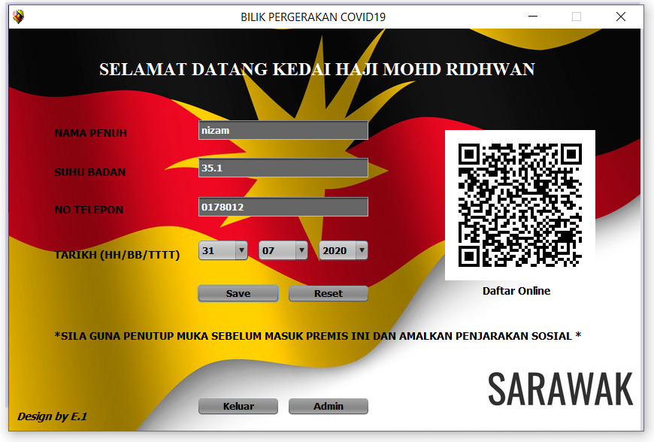

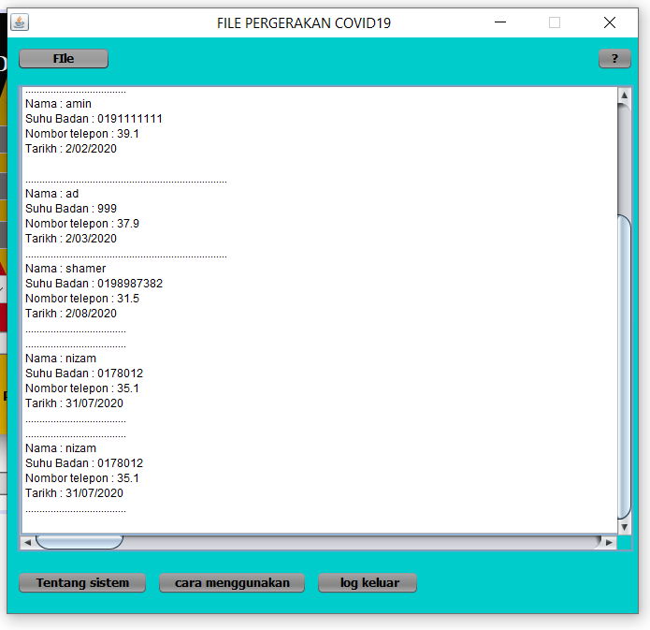

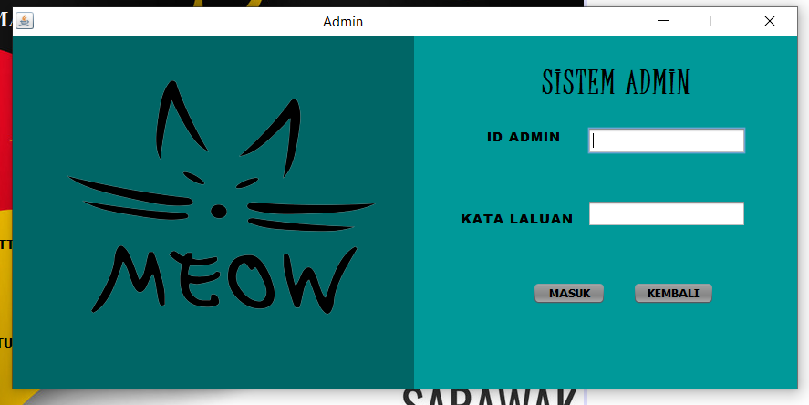

User manual/ How to use this system

1. Main system and customer will insert all data that system need

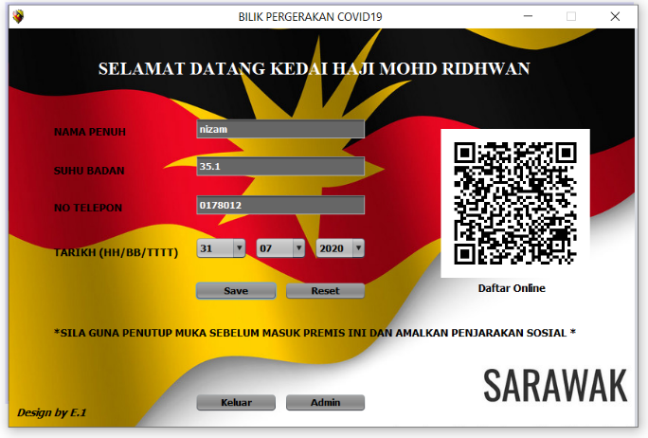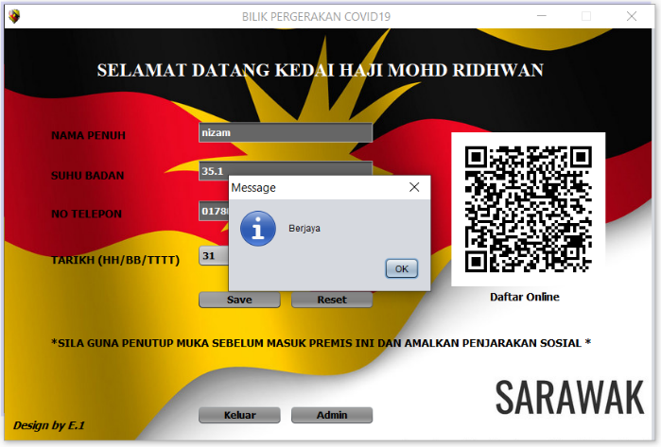

1. 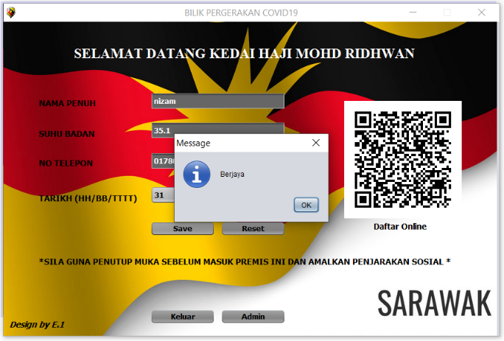Message “berjaya” will pop out if customer click save
2. 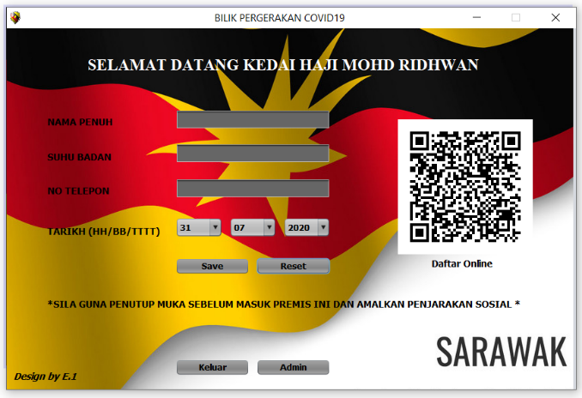Button admin just for admin to check all data customer

1. This is admin page only can log in by admin. Id admin and kata laluan is admin.



1. 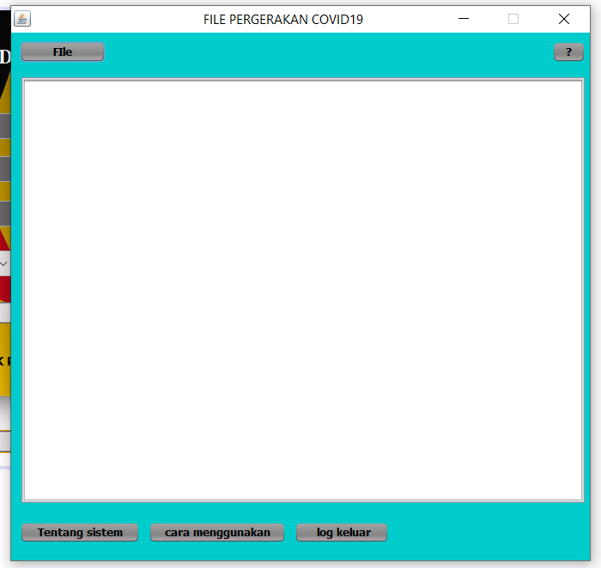this is place where all data from customer save
2. Find file name “Data Pelanggan”

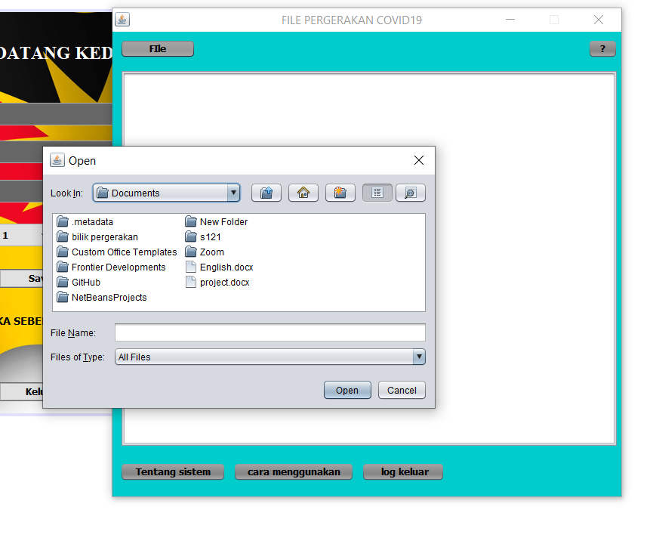

1. This is all customer data
2. Output “tentang sistem”

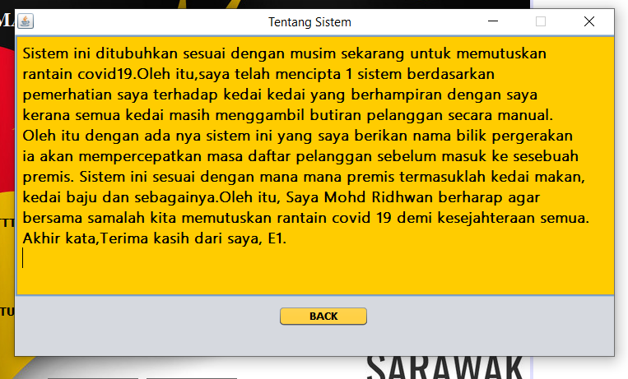

1. Output “cara penggunaan sistem”.

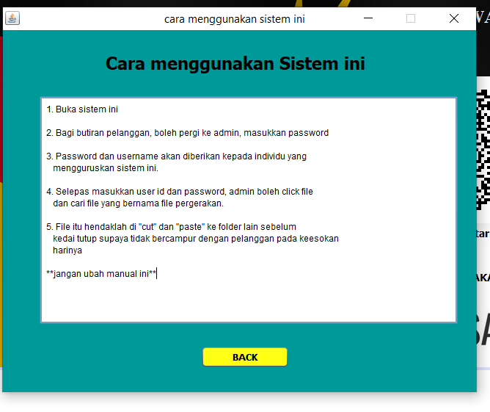

1. 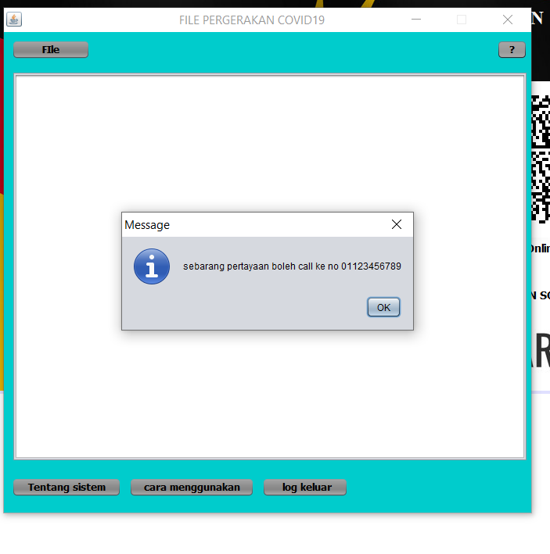Output popout contact number